MCADAMS LADY GATOR CROSS COUNTRY SCHEDULE

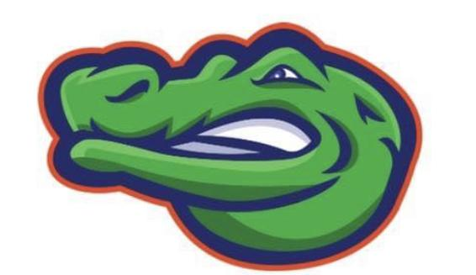

**First practice Oct 16, 2024**

**DATE HOST OPPONENTS**

**Oct 28th CREEKSIDE** DJHS, KJH,BYIS,CCIS, LCIS

**Nov 4th SEABROOK** BYIS, LCIS, CCIS, CLIS, DJH

**Nov 11th FRIENDSWOOD** SCIS, WBIS, CLIS, LCIS, SIS

**Dec 2nd** **Challenger District Preview** ALL TEAMS

**Dec 9th Challenger District** ALL TEAMS

**\*Races start at 4:45 or once all teams are present**

**\*Race Order: 7th Grade, followed by 8th grade**