MCADAMS LADY GATOR SOCCER SCHEDULE
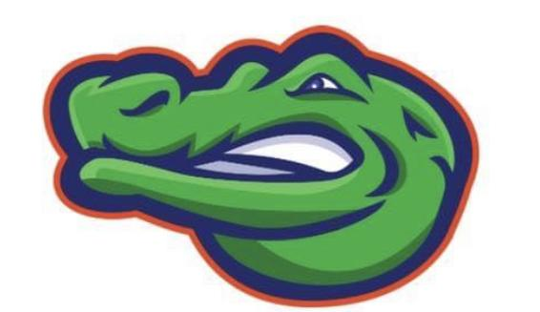
First practice March 19th

DATE OPPONENT LOCATION
Mar 27th Kranz Kranz
Apr 2nd Creekside Creekside
Apr 11th Friendswood McAdams
Apr 18th Victory Lakes Victory Lakes
Apr 25th Bayside McAdams
May 2nd Dickinson JH Dickinson JH
May 9th Brookside (ND) McAdams

*B Team Kickoff starts at 4:45, A team plays 10 minutes after B team ends

