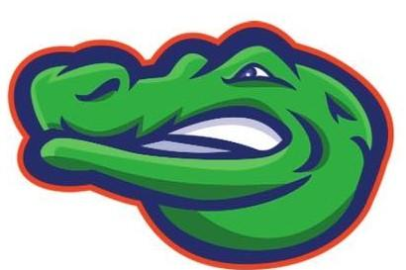
2022 McAdams
Girls Track Schedule

DATE | OPPONENT | LOCATION
Feb. 16 | DUAL PRACTICE MEET | TBD
Feb. 22 | SEABROOK, CLEAR CREEK, CLEAR LAKE, VICTORY LAKES, KRANZ | Clear Falls High School
Mar. 1st | BROOKSIDE, KRANZ, SEABROOK, CLEAR LAKE, VICTORY LAKES | Dickinson High School  (hosting)
Mar. 8th | BROOKSIDE, CLEAR CREEK, KRANZ, CLEAR LAKE, SEABROOK | Clear Brook High School
Mar. 22st | BAYSIDE, CREEKSIDE, LEAGUE CITY, CLEAR CREEK | Clear Falls High School
Mar. 27th | RUNNING PRELIMS | Challenger Stadium
Mar. 28th | FIELD EVENTS + GIRLS 3,200 | Challenger Stadium
Mar. 29th | RUNNING FINALS | Challenger Stadium

Coaches: Coach Menotti, Coach Bitner, Coach Miller, Coach Dobson

