MCADAMS LADY GATOR TENNIS SCHEDULE
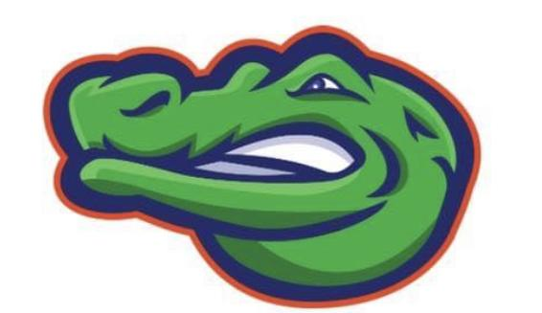
First practice/Tryout February 26th

DATE HOST OPPONENTS
March 4th CLEAR LAKE HS CL, FW, MJHS
March 21st CLEAR BROOK HS BS, CC, MJHS
March 25th DICKINSON HS KJH, DJH, MJHS
April 2nd SEABROOK INTERMEDIATE SB, MJHS

*Matches start at 4:45pm

DISTRICT TOURNAMENT APRIL 10TH
ALL 8th
Grade Singles and Doubles at Clear Creek HS
ALL 7th Grade
Singles and Doubles at Clear Lake HS
ALL 3rd Doubles are at CCI
District Matches start at 2pm

