Freedom Run

Cross Country Invitational

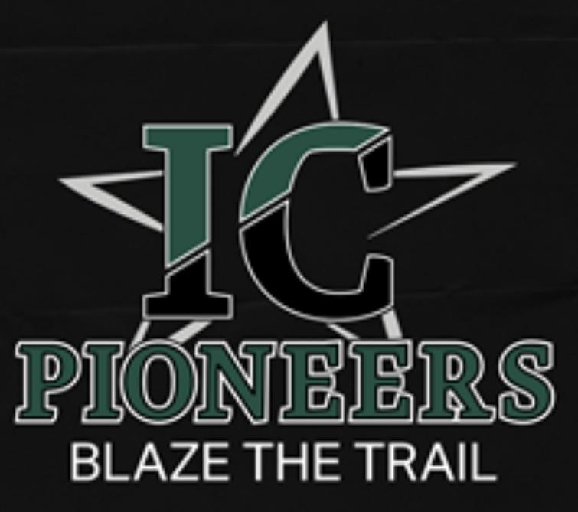

The Alvin I.S.D. XC teams will be hosting the 4th Annual Alvin I.S.D. Freedom Run Cross Country Invitational this year. We hope that you can attend our meet this season.

When: Friday, September 27th

Time: 8:00 a.m.

Where: Bob Briscoe Park 3625 Briscoe St, Alvin, TX 77511

Cost: **$60 per gender.**

Payment:

TBA

Schedule :

**Varsity Boys 5K- 8:00 am**

**Varsity Girls 5K- 8:30 am**

**JV Boys 5K- 9:00 am**

**JV Girls 3200- 9:30 am**

**Freshman Boys 3200- 10:00 am**

Medals for the top 15 finishers of each division will be handed out in the chute. **If you have any questions please feel free to email Marie Meng at mmeng@alvinisd.net.**