
Dear Cross Country Coaches,
Galveston Ball will be hosting its scholastic cross country meet on Friday, September 6, 2024.

The entry fee will be $60.00 per team, per gender ($120.00 for both) for schools participating in the Athletic Director’s Agreement. The fee will be $100 per gender ($200 both boys/girls) for schools not in the A.D.A. There will be two divisions: Division I will be composed of stronger 5A/6A schools. Division II will consist of smaller schools and other large school. If you have a preference, please let me know early. Both divisions will be divided equally. The course will be on the beach 95 -100 % on packed sand. We will send a map with details as time gets closer. All timing will be done electronically. There will be a limit of 15 runners per school in each varsity division. This should help lighten the JV races. No limit to the number of runners you may enter in the JV and freshmen divisions. Below is a tentative time schedule.
7:30 am All Divisions Check-In
8:00 am Division I Varsity Boys
8:30 am Division I Varsity Girls
9:00 am Division II Varsity Boys
9:30 am Division II Varsity Girls
10:00 am Junior Varsity (Boys) 3-mile course
10:30 am Junior Varsity (Girls) 2-mile course
11:00 am Freshmen Boys (ONLY) 2-mile course
11:30 am Freshmen Girls (ONLY) 2-mile course

These times are approximate. We will run on a rolling schedule after the first race, but plan to finish by noon. There will be medals for the first 20 finishers in each division. Make checks payable to:
Ball High
4115 Avenue O
Galveston, TX. 77550
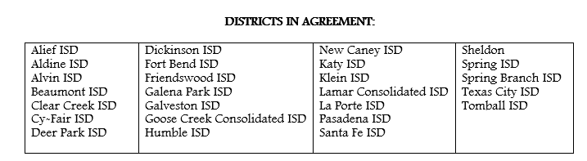
Email entry confirmation to aarondeyon@gisd.org. Entry deadline is 8pm, Monday, September 2nd !! We do not need names at this time; only if you plan to attend, an e-mail address and contact number. Thank you!!
Important Information
- MileSplit will be the official website used for event registration. (Password- beachrun24)
- There will be free parking for busses. Cars will be charged.
This is a business day and the facility will be open to the public also.
- Event Headquarters – East Beach Pavilion – Both the start and finish lines will be in this area. Staging and general access to restrooms, showers, and concessions will be in this area.
- Our Athletic Trainers and staff will cover the event. No Lifeguards will be on duty.
- The street address for the pavilion is 1923 Boddeker Road, Galveston, Tx. 77550.
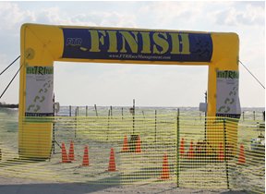
- Entry fees will not be refunded due to weather. Special situations will be considered.

