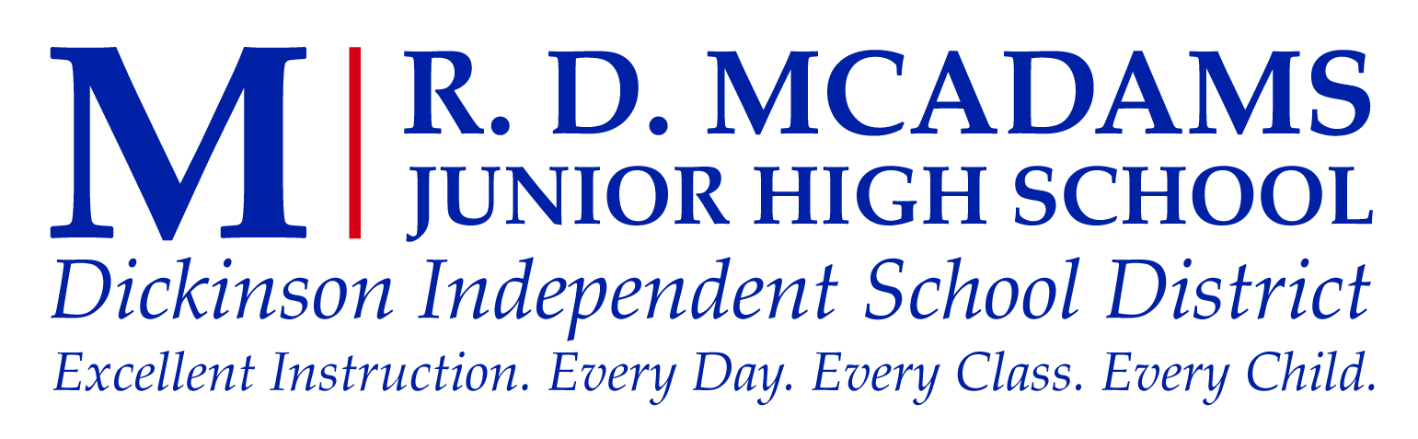

Teacher: Course: Dance Class (7th and 8th Grade)
Ms. Cordero (7th Grade)
Ms. Wright (8th Grade/Royals Dance Team/Cheer) Email:
7th Grade- jcordero@dickinsonisd.org
Dance Room/s: D117 and D104 8th Grade- bwright1@dickinsonisd.org

Phone: Office Hours:
Mrs. Christmas 281-229-7185 TBD in Room D105
Ms. Wright 281-229-7158

Introduction: The vision of McAdams Jr. High is, All students will learn. Every adult will do whatever is necessary to ensure all students learn.

Grade Breakdown:
Daily Work (dressing out and participation) | 45%
Tests, Projects and Major Assignments | 40%
Curriculum-Based Assessments | 10%
Homework | 5%

Grading Scale:
A= 100-90 | B= 89-80 | C= 79-75 | D= 74-70 | F= Below 70

Course Goals/Information: Students will be able to execute technical dance elements appropriate to class level. They will be able to develop a greater appreciation of various forms of dance and learn about the history of different styles. Vocabulary will be learned including dance movements and human anatomy. Most importantly, students will learn to improve overall physical coordination, balance, flexibility, and fitness for future interest in dance or fine arts.

SUPPLIES AND DANCE ATTIRE (45% of dance grade):
- All students are required to purchase 1 pair of black or tan jazz shoes, which will be worn EVERY DAY in class. For 7th Grade, students will only need to purchase this once, and reuse for 8th grade dance (if they are taking dance as an elective again). No socks or tennis shoes while dancing, it is easy to slip and fall- not appropriate dance shoes. Jazz shoes will be due in class on SEPTEMBER 12th. Just as in PE, the student will need to wear these in order to receive full credit for their daily grade.
- Required SOLID Black Top- form fitting shirt that COMPLETELY COVERS STOMACH. Tank tops are acceptable ONLY if the straps are 3 inches wide or more. Black Leotards are also acceptable. Often it might be chilly in the dance room; a jacket for the first 5 minutes of warm up is acceptable.
- Black Bottom- Black dance pants or capris. Capri length pants, “nike” shorts, Bermuda length shorts, and long jazz pants are fine. No cheer shorts or hot shorts- too short! Hair must be up in a ponytail or bun, out of face EVERY DAY.
- Write your name on the inside tag of ALL clothing and shoes for dance. It is very easy to misplace or accidentally take another students belongs while changing.
- Students will be asked to remove oversized jewelry for safety purposes (this is also a part of their daily grade).
- Writing Materials- ONLY Pencils and a 100’ Page spiral any color are due SEPTEMBER 7th (lecture day). Pens/markers are not allowed, and points will be taken off if used.
These items can be purchased at Backstage Dance Wear, any Wal-Mart, Target, Dance Store, Academy, and fitness departments.
Grading System:
- 20 points will be given each day, making a total of 100 at the end of each week.
- VERY IMPORTANT: Each student is required to dress out every day, whether or not they are excused from participation that day. Students who forgot their clothes will dance in their school clothes. NO EXCUSES!
- Deduction Points

- -10 Not dressed out completely (partial doesn’t count!)
- -20 Absent (until made up)
- -5 Excessive talking
- -5 Gum chewing
- -5 Jewelry
- -10 Failure to participate fully or failure to follow instructions
- -5 Hair not up

Absence Policy: Upon returning from your absence, you must have an excused absence recorded and shown to me at the beginning of class. Make sure you have taken care of this in the office for all teachers. A one-page handwritten paper on any dance related topic is required for each day that you are absent to re-gain participation points. You have one day per day absent to complete this assignment.
Late Work Policy: Any student will be deducted 10 points each day off their grade after the given due date. After 5 days late, the student will receive a zero for that assignment. School related absences do not require a make-up paper, but you must let your teacher know ahead of time.
Discipline: Students must participate to the best of their ability, display respect for others at all times, and will refrain from excessive talking or participation points will be deducted. Leaving class without permission is considered truancy and a referral will be written. Lunch detentions will be given under the teacher’s discretion and missing a lunch detention will result in a referral. The rules set forth in the MJHS student code of conduct will be enforced in this class.

Dance Class Performances/Dance Department Fundraisers:
Winter Showcase- December 1st at 6:00pm, MJHS Auditorium
Student Choreography Showcase- May 11th at 6:00pm, MJHS Auditorium

Dance Performance/Project Requirements:
Each student is required a Final Grade in Dance for the first and second semester. They have the option of participating in each semester showcase in order to be excused from the final project. If they are not able to perform, they will still be required to learn the dance and participate each day in class. Along with not performing, a dance project (final grade) will be given 1 month prior to the showcase, and needs to be worked on at home. If a student receives a referral in dance class (within the current semester), they will not be given the option to perform, therefore the project/presentation is mandatory. This project and presentation will be due the day of the showcase during class. A parent letter/ student agreement will be sent home on the following days, and is required to be signed and returned:
- November 1st (Tuesday) for the Winter Showcase
- April 11th (Tuesday) for the Spring Showcase

This agreement will include the decision to do the project or showcase. More information such as ticket information and student requirements will be provided at this time as well. If a student does not show up for the showcase, they have chosen to receive a zero for their final project, knowing that their project was due the day of the show during class. All students who are performing will be EXPECTED to remain backstage throughout the entirety of the showcase in order to still be excused from their final grade project. NO PARENTS ALLOWED BACKSTAGE! Tickets for each showcase will be $5.00 and will be sold 2-3 weeks prior to the show. There is no guarantee that tickets will be available the day of the show.

Dickinson Independent School District Academic Integrity Guidelines

It is the policy of Dickinson Independent School District to facilitate honesty and integrity among the student body. Students must work to be successful in the classroom, each on his/her own merits.
Academic misconduct can be defined to include but not limited to, giving or receiving of unauthorized aid on examinations or in the preparing of notebooks, themes, reports or other assignments, knowingly misrepresenting the source of any academic work; unauthorized changing of grades; unauthorized use of school approvals or forging of signatures, plagiarizing of another’s work, or otherwise acting dishonestly in the classroom.
Academic misconduct of any kind is unacceptable and will result in disciplinary consequences. The student’s parent will be notified, and the student will be given an alternate assignment. The maximum grade a student can earn on the alternate assignment is a 70. Repeated offenses may jeopardize the student’s ability to successfully complete the course.
Examples of Academic Misconduct
Cheating – giving, using, or attempting to see unauthorized materials, information, notes, study aids, or other devices in any academic exercise, including unauthorized communication of information
Fabrication or Falsification – unauthorized alteration or invention of any information or citation in an academic exercise
Plagiarism – knowingly presenting the work of another as one’s own (i.e. without proper acknowledgement of the source). The sole exception to the requirement of acknowledging sources is when the ideas or information are common knowledge. This includes the use of Internet sources.
Facilitating Academic Misconduct – giving or attempting to help another commit an act of academic misconduct
Tampering with Materials, Grades or Records – interfering with, altering or attempting to alter school records, grades or other documents without authorization from an appropriate school official for the purpose of changing, falsifying or removing the original information found in such records
Copyright Laws – All applicable copyright laws will be in effect as related to both computer software and printed materials. [See the Dickinson ISD Board Policy EFE and the Technology Acceptable Use Policy.]

Parents and students please sign below showing that you have read the syllabus for Ms. Wright and Ms. Coredo and understood the expectations, rules and class procedures. Please print clearly.

_____________________________ _____________________________
Student signature Student Name (printed)

_____________________________ _____________________________
Parent signature Parent Name (printed)

_____________________________ _____________________________
Parent e-mail Parent contact #

*Class Period
___________

