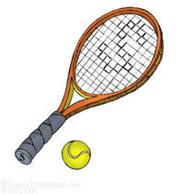
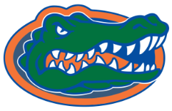
Dickinson Gator Spring Tennis Schedule
Varsity
January 13 Dickinson Intra-Squad Tournament @DHS
January 20 Baytown ISD Tournament
February 10 Pasadena ISD Tournament
February 17 Deer Park Tournament
February 24 Clear Brook Tournament
March 3 La Porte Tournament
March 8 Montgomery Tournament
March 31 Galveston Beachcomber Tournament
April 5-6 District Tournament @ Clear Brook
April 14 Gator Student Faculty Doubles Tournament

Dickinson Gator Spring Tennis Schedule
Junior Varsity
January 13 Dickinson Intra-Squad Tournament @DHS
January 26 Wilson Blast Tournament @Dobie
February 7 Pasadena Tournament
February 14 Fort Bend Tournament
February 23 Alvin Tournament
February 28 Baytown Tournament
March 7 Deer Park
March 22 Clear Brook Tournament
April 14 Gator Student Faculty Doubles Tournament @DHS
April 21 District Tournament
Freshman
January 13 Dickinson Intra-Squad Tournament @DHS
January 26 Wilson Blast Tournament @Dobie
January 31 Pasadena ISD Tournament
February 21 Galena Park Tournament
February 28 Fort Bend ISD Tournament
March 21 Alvin Tournament
April 14 Gator 1st annual Student Faculty Doubles Tournament @DHS
April 21 District Tournament

